**Documentation**

The following are source code on what each file does in our programs

**Initialize_data.py:** This function populate our teacher and students data into students.dat/ teacher.dat. Each student/teacher contains ID, first and last name. While student also contains their classes currently enrolled in.

**inputError.py:** This function checks if any user inputs are correctly match with the data type in the function. For an example if a letter is inputted to calculateGPA average, it throws an error since the average cannot be with a letter.

**Courses.py:** This class controls all the courses modification for the teacher login is. In the function “ addGrade()” it adds new scores to the students and calculate their GPA. The “calcGPA” Adjusts the GPA of the student based on values in grades[]

This function is automatically called by addGrade() each time a grade is added to update the GPA.

**Student.py:** This class contains all the actions the students can perform. 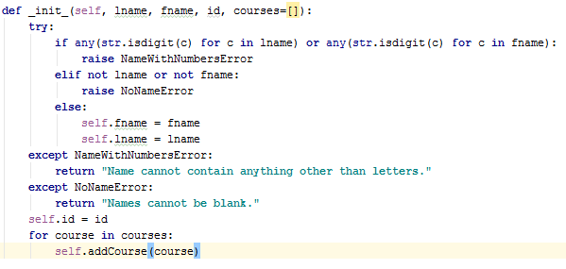

This function checks if the user inputs are not out of scope of the program. Students can add new courses to their profile and view all the courses they are currently enrolled in.

**Teacher.py:** This class store/ assign the teacher’s first, last name and password.